# CS 255 System Design Document

## UML Diagrams

### UML Use Case Diagram

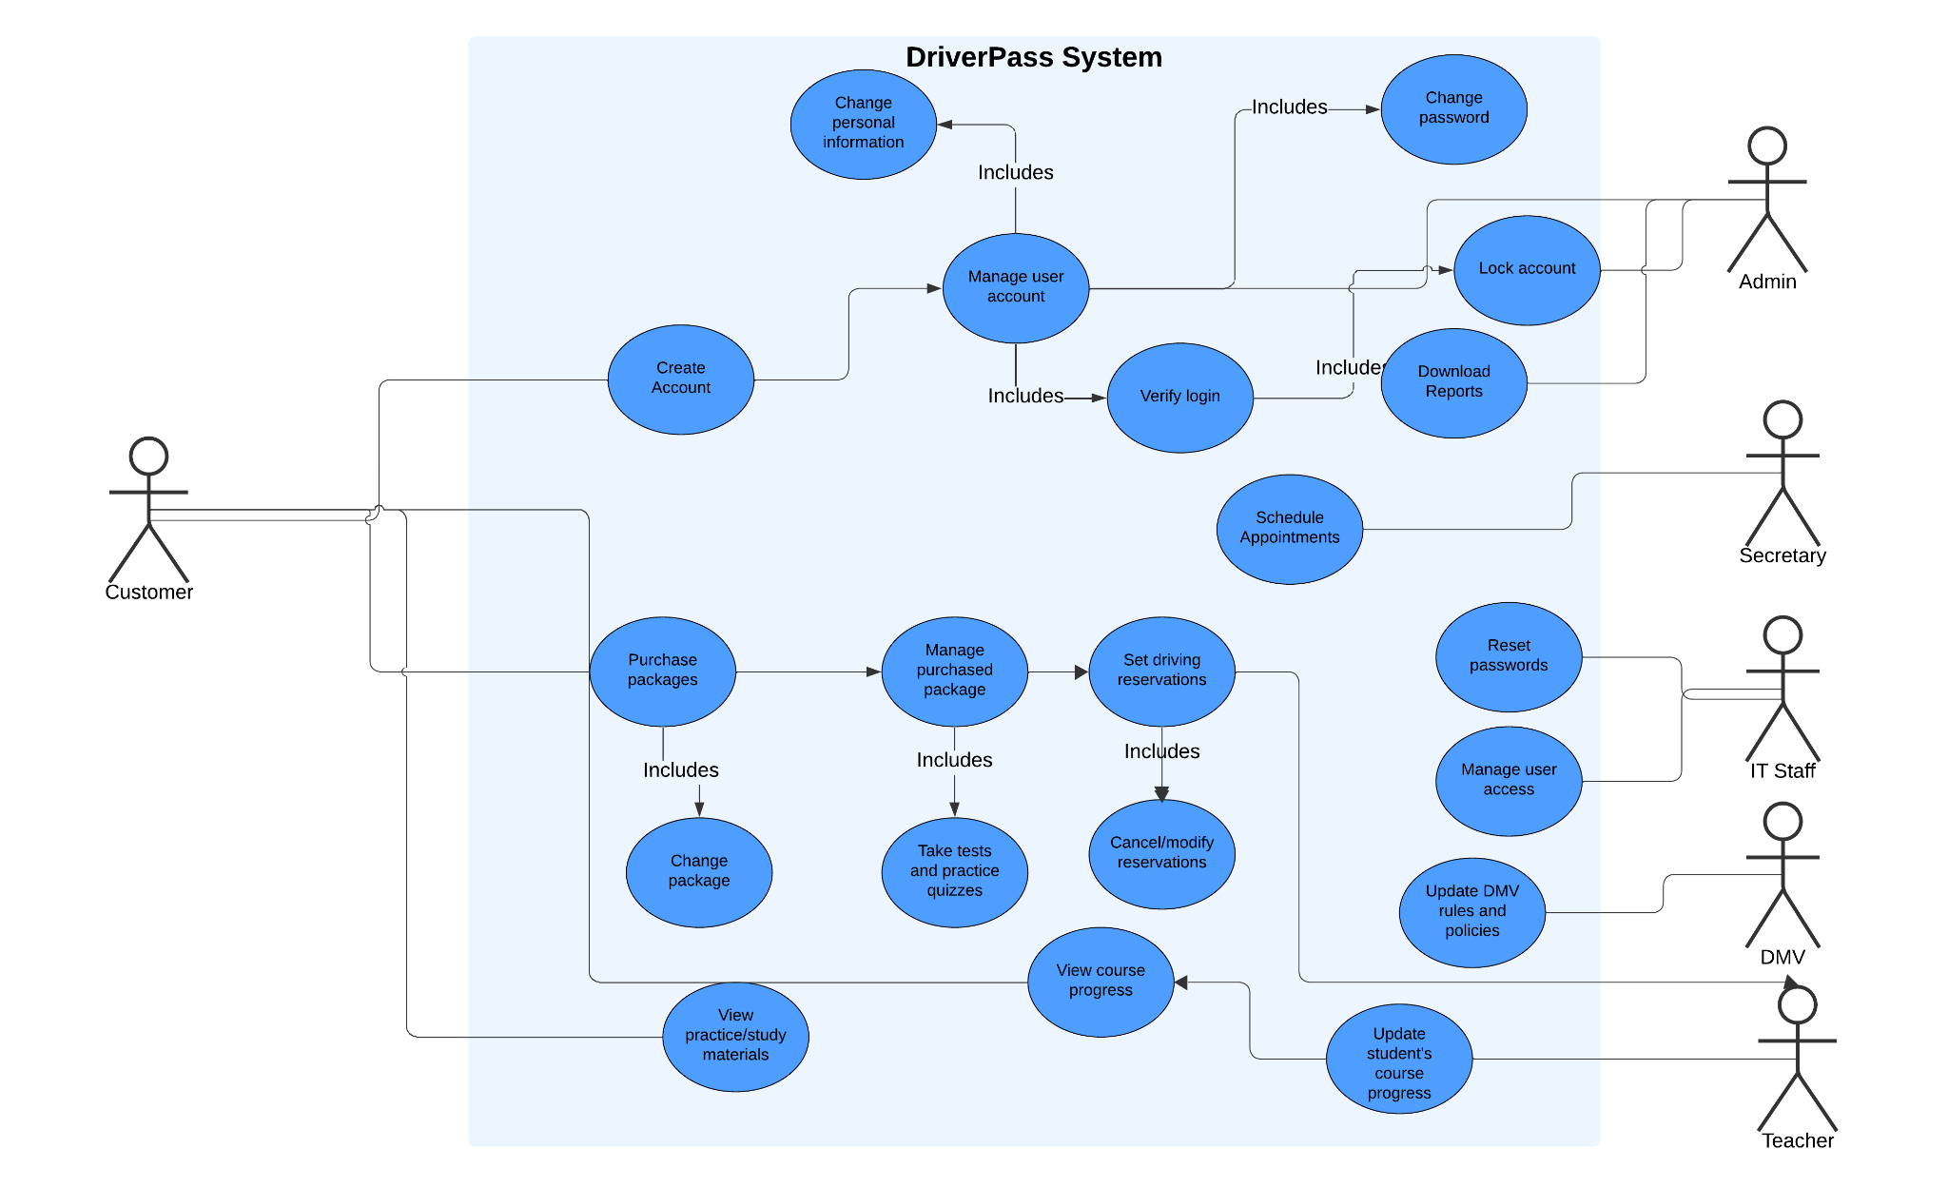

### UML Activity Diagrams

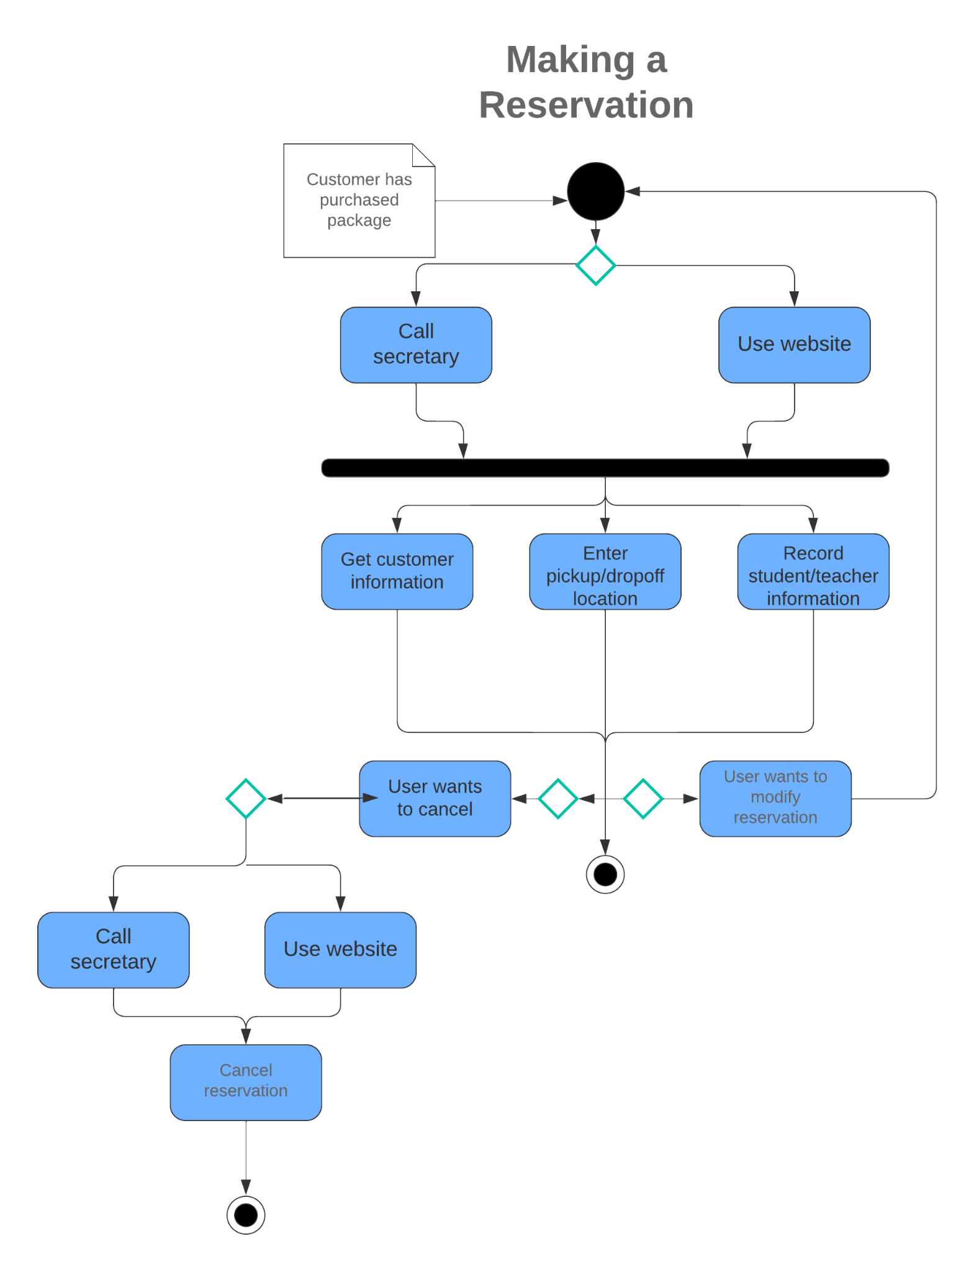

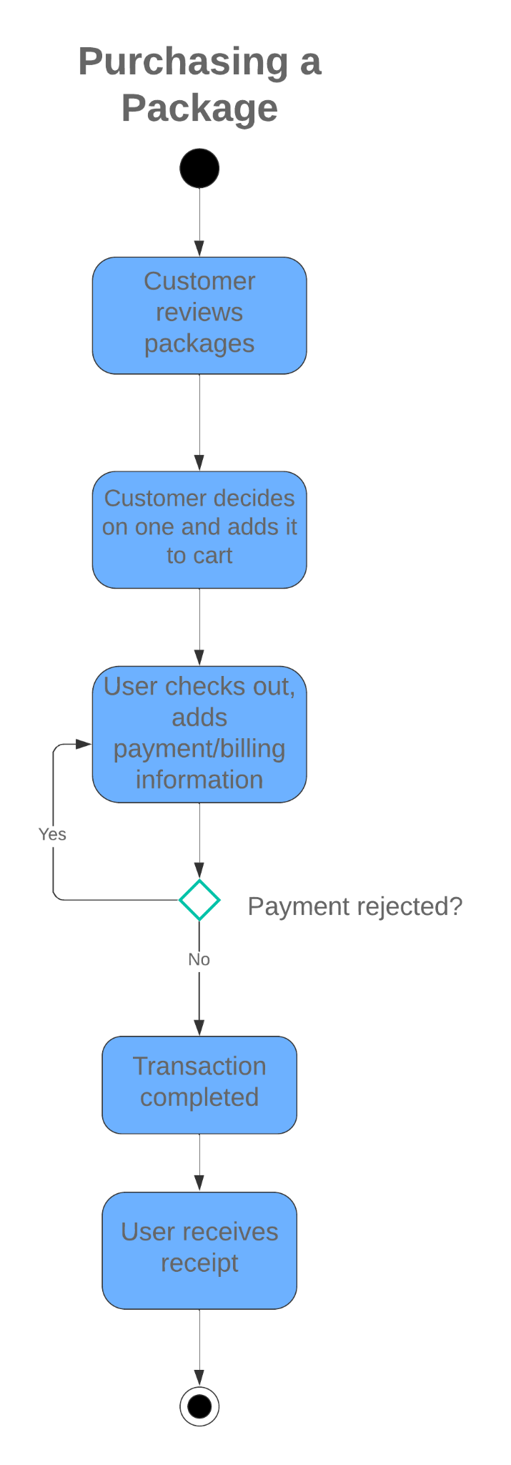

### UML Sequence Diagram

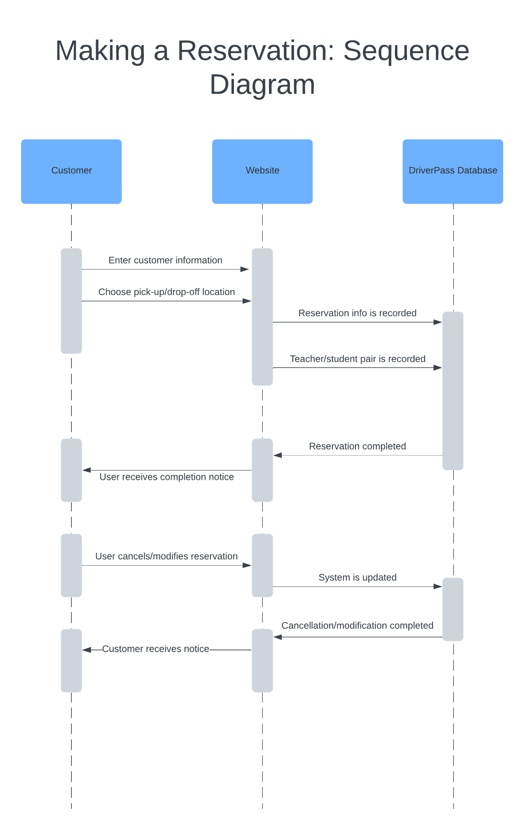

### UML Class Diagram

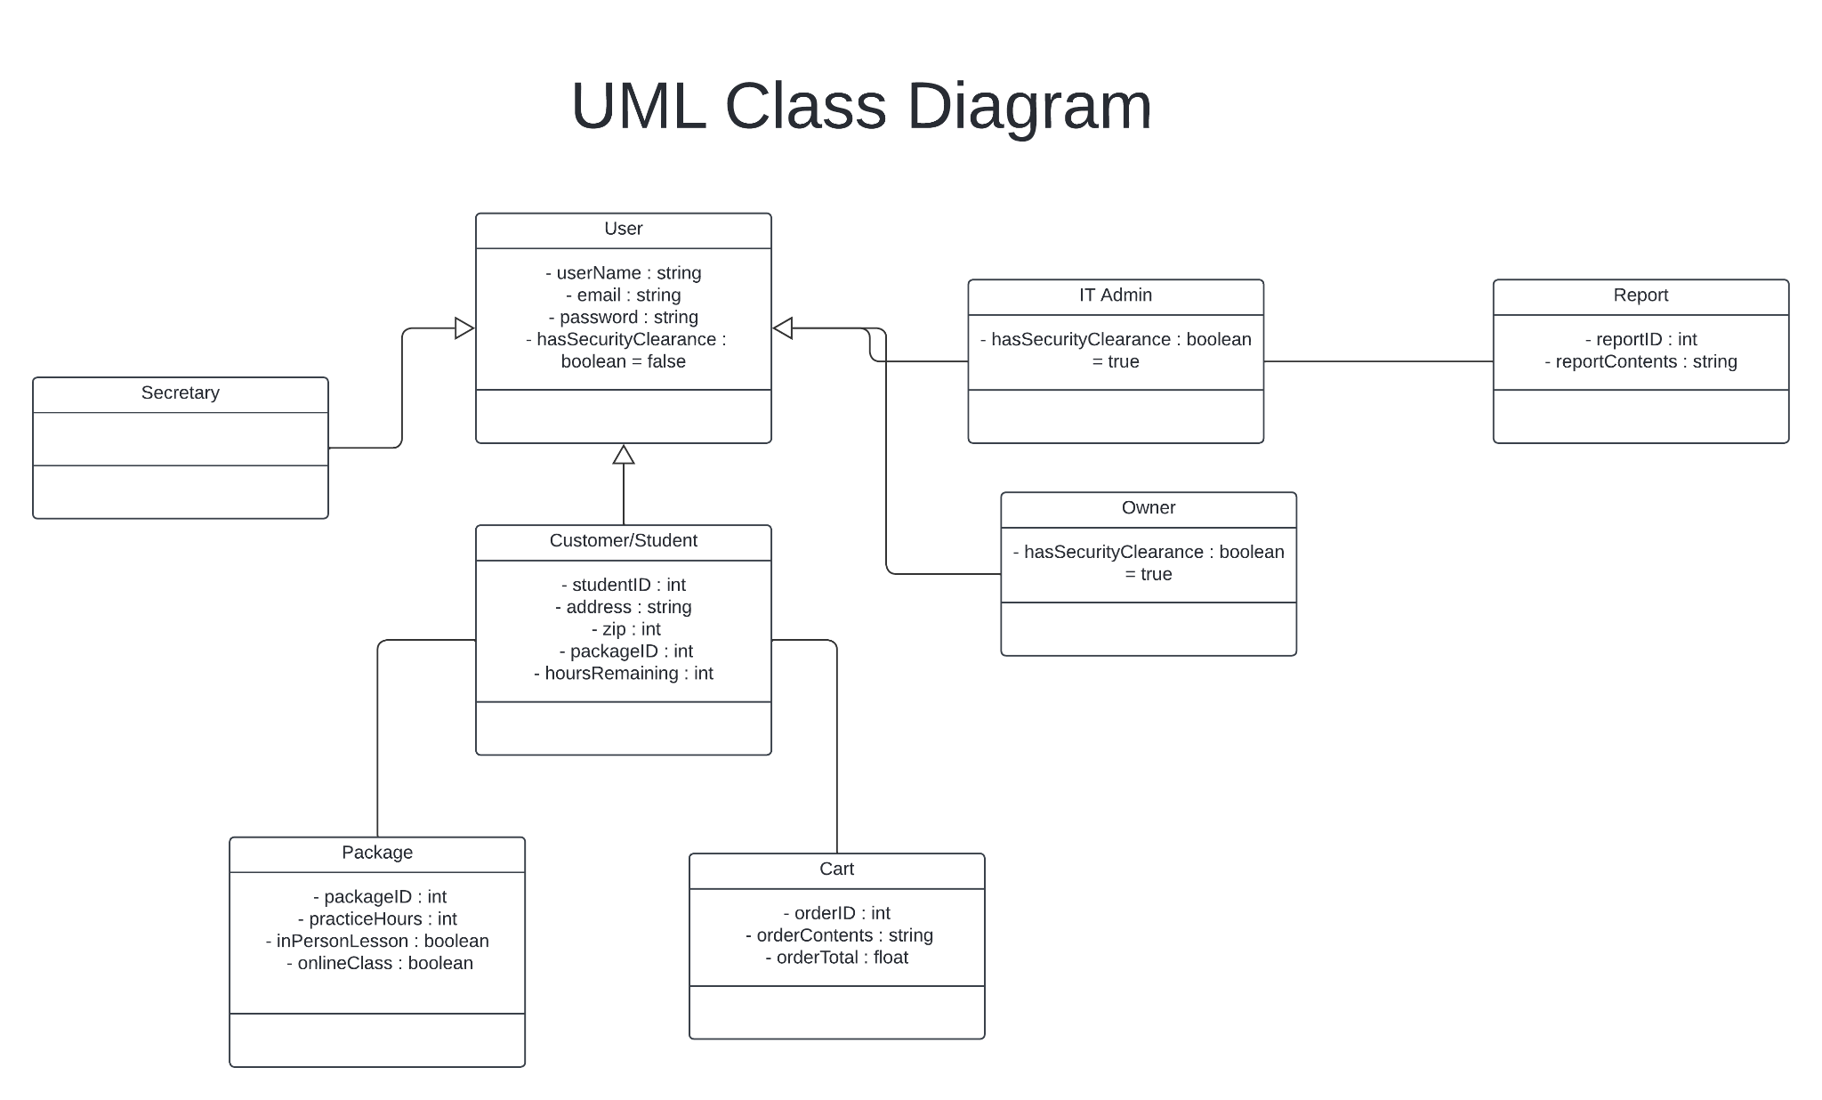

## Technical Requirements

* System shall be web-based and compatible with every major web browser
* System will need a cloud based database to handle data storage
* System requires a dedicated back-end server to handle requests
* System requires internet access to interact with
* User will need to have an appropriate device to access system (desktop or mobile device)
* Website should be available to all in the US
* Security software will be necessary to protect users